Initial conditions
Initial conditions from testbench: 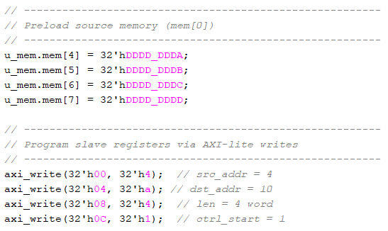
Memory locations 4 through 7 were initialized with data. Using the DMA, these values were then copied to memory locations 10 through 13.

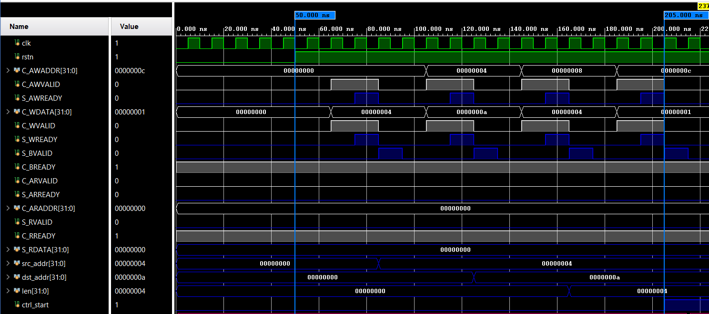
Waveform for cpu<->axi slave

Waveform Analysis (with write response):
The waveform shows the CPU writing to the AXI slave to initialize the source address, destination address, transfer length, and control start registers.
- Signal coloring: CPU outputs are white, slave outputs are blue.
- After reset at 50 ns, each register is programmed through a standard AXI-Lite write transaction:
  - The CPU asserts AWVALID (address) and WVALID (data) for the target register.
  - The slave responds with AWREADY and WREADY, completing the address and data handshakes.
  - After the write handshake, the slave asserts BVALID to indicate that the write has been successfully captured. The CPU asserts BREADY to acknowledge this response.
  - Once BVALID & BREADY handshake occurs, the internal register in the slave is updated (visible at the bottom of the waveform: SRC_ADDR, DST_ADDR, LEN, CTRL_START).
- Each register write (source address, destination address, length, control) is clearly observable as a sequence of AWVALID/WVALID → AWREADY/WREADY → BVALID/BREADY handshake events.
This shows that the CPU successfully programs the DMA through the AXI-Lite interface and that the slave correctly acknowledges each write via BVALID.

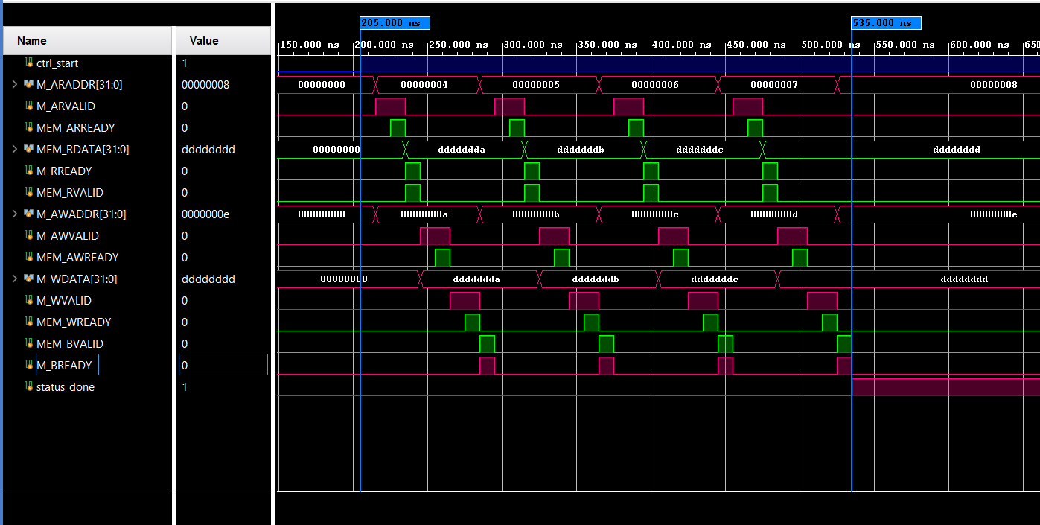
Waveform for dma_core<->axi_lite_mem
Waveform Analysis – DMA Core and AXI-Lite Memory:
In this waveform, we observe the interactions between the DMA core (acting as master) and the AXI-Lite memory module (acting as slave). The transfer consists of 4 transactions as intended, with each transaction performing:
- Read from the source memory address.
- Write of the read data to the destination memory address.
Signal coloring:
- Purple: DMA core outputs
- Green: Memory module outputs
Handshake details for each transaction:
- Read Address Channel:
  - The DMA core asserts ARVALID and sets ARADDR to the source address.
  - The memory asserts ARREADY one cycle later.
  - The ARVALID & ARREADY handshake completes, and the DMA knows the read address is accepted.
- Read Data Channel:
  - Memory asserts RVALID with the data at the requested address.
  - DMA asserts RREADY to accept the data.
  - The RVALID & RREADY handshake completes, and the DMA captures the data into its internal buffer.
- Write Address Channel:
  - DMA asserts AWVALID with the destination address on AWADDR.
  - Memory asserts AWREADY one cycle later.
  - The AWVALID & AWREADY handshake completes, indicating the memory is ready to accept the write.
- Write Data Channel:
  - DMA asserts WVALID with the data read from memory on WDATA.
  - Memory asserts WREADY one cycle later.
  - The WVALID & WREADY handshake completes, and the data is written into the destination address.
- Write Response Channel:
  - Memory asserts BVALID to indicate the write has been successfully stored.
  - DMA asserts BREADY to acknowledge the response.
  - The BVALID & BREADY handshake completes, marking the end of one full transaction.
Observations:
- Each of the 4 transactions follows this exact sequence.
- All read and write handshakes are visible and occur in the correct order.
- Source memory content is correctly read and written to the destination addresses as intended.

Memory contents
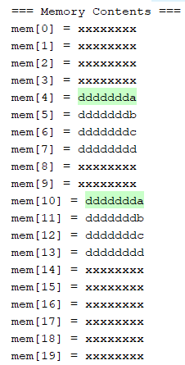
The memory was initialized with values in locations
mem[4]->mem[7].
After DMA transfer, those values were successfully copied into
mem[10] ->mem[13] as intended.

